1. Free or public API : FREELY accessable
2. WEBSITE TO GET THE FAKE API FOR TESTING

| **http://jsonplaceholder.typicode.com/** |
| --- |
| **http://httpbin.org/** |
| [**http://fakestoreapi.com/**](http://fakestoreapi.com/)  **{The above webpage only responds to API requests and not the web browser requests}** |

1. <https://fakestoreapi.com/products?limit=7>

Fakestore is only designed to respond to the API requests that are sent to it and not the web browser requests. Hence when the user attempts to access the webpage there are no results that are returned.

1. : Path variable in the API URL request

In the URL https://jsonplaceholder.typicode.com/posts/:id, the colon (:) specifies a route parameter or a path parameter.

In this case, :id is a placeholder for a dynamic value that will be replaced with an actual value when the request is sent.

When you send a request to this URL through Postman, you need to replace :id with a specific value, such as 1, 2, or 3. This value will be used to retrieve a specific post from the JSONPlaceholder API.

Here's how you can do it in Postman:

1. Enter the URL https://jsonplaceholder.typicode.com/posts/:id in the request URL field.
2. Click on the Params button next to the URL field.
3. In the Params section, you'll see a key-value pair with id as the key and an empty value field.
4. Enter the desired value for id, such as 1.
5. Click Send to send the request.

The resulting URL will be https://jsonplaceholder.typicode.com/posts/1, and the response will contain the post with the specified id.

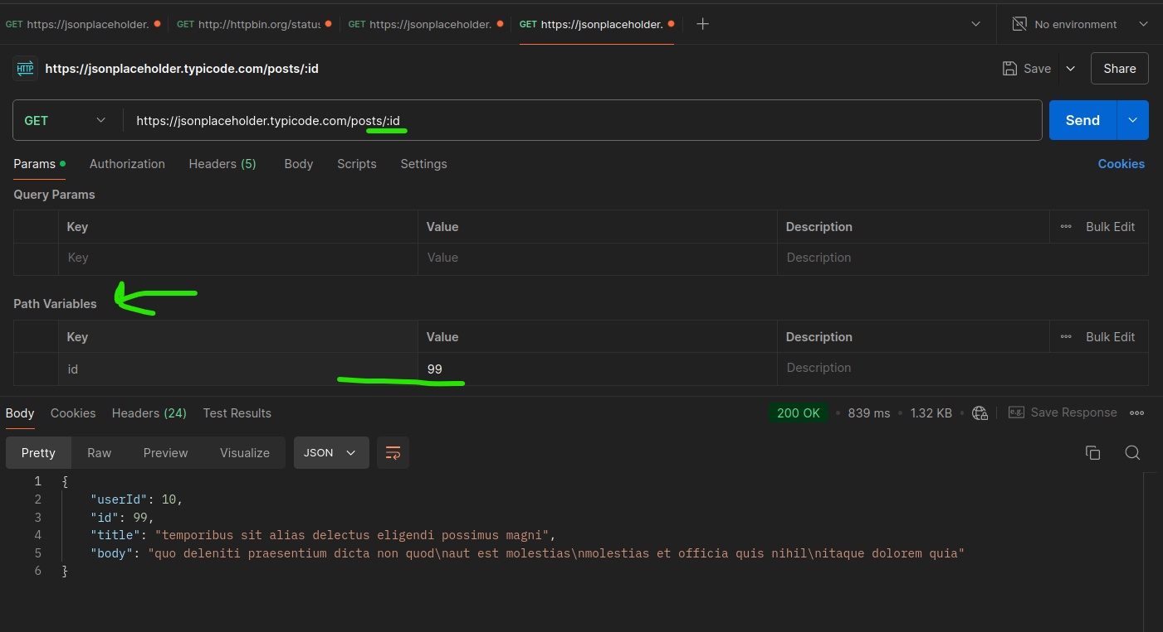

Colon is not required to be at the end of the URL; it can be in the middle as well.

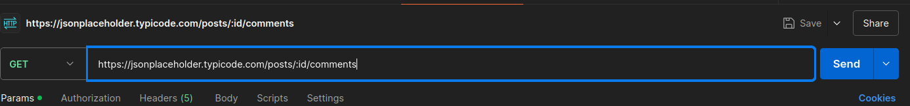

1. PARSE THE HEADERS THAT ARE SENT WITH THE REQUEST

If you send a request to **http://httpbin.org/headers** in Postman, the URL will parse and return the HTTP headers sent with the request.

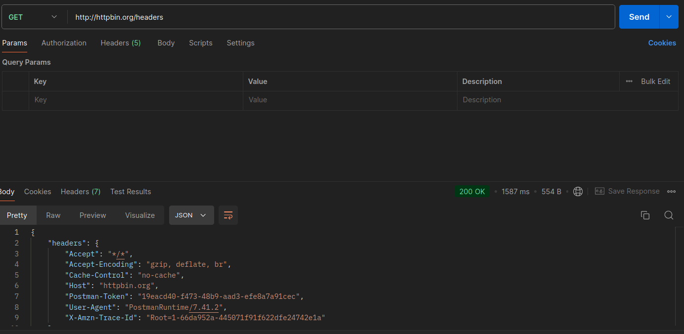

We cannot delete the mandatory headers like host and accept from the web version.